Comparison of condensation heat transfer coefficient and pressure drop in horizontal smooth and micro-fin tube

Project supervisor – Dr Rajeev kukreja

Submitted by – Ritika kaushik (19109082)

Priyanshu bansal (19109073)

Devraj gurjar (19109033)

Mahaveer Meena (19109060)

Deep Panchal (19109029)



DEPARTMENT OF MECHANICAL ENGINEERING

Dr BR AMBEDKAR NATIONAL INSTITUTE OF TECHNOLOGY JALANDHAR (PUNJAB)-144011

CERTIFICATE

This is to certify that the project report entitled Comparison of condensation heat transfer coefficient and pressure drop in horizontal smooth and micro-fin tube submitted by ritika kaushik, mahaveer meena, devraj gurjar, deep panchal, priyanshu bansal to the Dr. B. R. Ambedkar National Institute of Technology Jalandhar, in partial fulfilment for the award of the degree of B. Tech in Mechanical Engineering is a bonafide record of minor project work carried out by him/her under my/our supervision. The contents of this report, in full or in parts, have not been submitted to any other Institution or University for the award of any degree or diploma.

Dr. Rajeev kukreja

ACKNOWLEDGMENTS

I take this opportunity to thank, Director - Dr. B. R. Ambedkar National Institute of Technology Jalandhar, Dean –Students Activities, and other faculty members who helped in preparing the guidelines. I extend my sincere thanks to one and all of NIT Jalandhar family for the completion of this document on the project report format guidelines.

Ritika kaushik

Devraj gurjar

Mahaveer meena

Priyanshu bansal

Deep Panchal

TABLES OF CONTENT

1. Introduction
2. why are microfin?
3. Performance evaluation factors
4. Motivation for the present study
5. Literature review and conclusions
6. Objective for present study
7. Graphs using EES
8. Result and discussion
9. About EES
10. Bibliography

NOMENCLATURE

A heat transfer surface area

cp specific heat capacity at constant pressure kJ/kg-K

D tube inner diameter m

Dh hydraulic diameter m

G mass flux

h heat transfer coefficient

heat transfer coefficient assuming liquid phase

flowing alone in the tube

heat transfer coefficient assuming all mass flowing

as liquid

two-phase heat transfer coefficient

Nu Nusselt number

Pr Prandtl number

Pcr critical pressure bar

Re Reynolds number

x mean vapour quality

Greek symbols

α apex angle or fins angle (degree)

β spiral or helix angle (degree)

η heat transfer area enhancement ratio

μ dynamic viscosity

ρ density kg/m3

χ tt Martinelli parameter

Subscripts

f = of liquid

g = of vapour

Introduction:

Condensers are a vital part of the refrigeration and air conditioning systems. The size and the weight of the system are one of the most current issues. Besides, the very tough concerned of the whole World is the bad influence to the global warming potential and ozone depletion from the current refrigerants. The performance of these systems is much affected by the condenser’s performance. Nowadays the lacking of energy resources led to the development of energy- efficient thermal systems particularly used in Refrigeration and Air Conditioning industries. Condensers used in conventional applications use smooth tubes. However, in the present work, a micro fin tube is used instead of a smooth tube. Micro-fin tubes use passive technique for heat transfer enhancement as it does not require any external power source and lower cost of modification. In present work, the experiments have been conducted to evaluate the performance of the micro-fin tube in comparison with the smooth tube in terms of heat Transfer Coefficient Enhancement Factor(EF) and Pressure Drop Penalty Factor(PF). Many research studies have been conducted towards the augmentation of heat transfer to increase heat transfer or to reduce the surface area for a given heat duty in condensers used for various applications,. Heat transfer enhancement or augmentation techniques refer to those techniques that increase the thermohydraulic performance of the heat exchangers. These techniques are classified as active, passive, and compound techniques, have been used these days for heat transfer augmentation in heat exchangers.

ACTIVE TECHNIQUES: These techniques require some external power input for causing the desired flow modification and enhancing the heat transfer rate. These techniques do not incur any pressure drop.

PASSIVE TECHNIQUES: These methods do not require direct input of external power; instead, they use it from the system itself, which ultimately leads to a drop of fluid pressure. They generally alter the surface or geometry of the flow channel by installing inserts or additional devices. Disruptions in the existing boundary layer lead to increased heat transfer coefficients. Surface roughness, displaced promoters, and vortex generators are some of the typical examples of Passive augmentation techniques.

COMPOUND TECHNIQUES: When any two or more of these techniques have been used in the same system for achieving a higher value of heat transfer coefficient which will be greater than that produced in the case if either technique is used individually, is termed as a compound enhancement.

Why are microfin tubes?

The micro fin tube is widely used in heat pump and refrigeration systems for its high heat transfer performance and relatively low flow resistance. Many kinds of micro fin tubes have been developed by different companies, and studied by many researchers.

Micro-fin tubes were first invented by Fujie et al. in 1977. Micro fin tube is a heat transfer pipe with the inner wall having the internal grooves not just for the sake of increasing heat transfer area only but also minimizing the pressure drop.

For minimizing the pressure drop of the flowing fluid, the grooves were provided with a spiral angle, which was an acute angle, relative to the axis of the heat transfer pipe. The spiral angle optimizes the micro fin tube by reducing the pressure loss with the heat transfer enhancement. Also, the height of the fins or depth of the grooves should have a specific value otherwise it will lead to offering a higher level of resistance to the fluid flowing through the heat transfer pipe resulting in a massive pressure loss. It also results in the variation of the condensation and evaporation temperatures and affecting the performance of the heat exchanger or the operating system as a whole.

Performance evaluation factors:

**Heat Transfer Enhancement Factor (EF)**

The heat transfer enhancement factor (EF) is the method that compares the performance of micro fin tube to the smooth tube at the same operating conditions. It is defined as the ratio between heat transfer coefficient for an augmented tube (for micro-fin tube) to that of a smooth tube operating under similar conditions and maximum inner diameter.

**Pressure Drop Penalty Factor**

Frictional pressure drop characteristic of the augmented tube is expressed in terms of pressure drop penalty factor (PF). The PF is defined as the ratio of frictional pressure gradient of a micro fin tube to that of a smooth tube at the same operating conditions at maximum inside diameter.

The augmentation technique, with the higher value of Heat Transfer Enhancement factor along with minimal pressure drop penalty factor, will be considered best

Motivation for the present study

In recent years, the use of energy systems, including refrigeration and air-conditioning systems, has been gradually increasing due to the advancement of technology and the improvement of living standards. At the same time, energy supply/demand and environmental problems are emerging as important issues. The environmental impacts of refrigeration and air-conditioning systems and their influence on global warming occur during the generation of the working fluids of the system and because of the power required for operation of the systems.

Global warming is highly affected by air-conditioning, refrigeration, and heat pump systems that account for 700 million metric tons of CO2-equivalent direct (7~19%) and indirect emissions (74%) per year. Therefore, it is very important to increase the energy efficiency of such systems and to use eco-friendly alternative refrigerants such as carbon dioxide and hydofluoro-olefin (HFO) refrigerants with smaller global warming potentials (GWP). Heat exchangers in air-conditioning and heat pump applications play an important role in the system efficiency and physical size. Finned, round tube, or flat tube heat exchangers are widely used for the evaporators and condensers in residential air-conditioning and heat pump systems.

To investigate the overall performance of the finned-tube heat exchangers, the tube-side heat transfer and pressure drop characteristics as well as airside performance should be investigated simultaneously. Several researchers have conducted investigations into the two-phase thermal and hydraulic performance in smooth and enhanced tubes. Kim and Shin experimentally investigated heat transfer characteristics during evaporation and condensation using R-22 and R-410A in 9.52-mm OD smooth and micro fin tubes. They found that the average evaporation and condensation heat transfer coefficients of R-410A for micro fin tubes were 1.86~3.27 and 1.7~3.1 times larger than those of smooth tubes, respectively

The objective of the present work is to investigate the condensation heat transfer and frictional pressure drop in the augmented tube in refrigeration and air conditioning systems. The present work is to provide vital information to the researchers and manufacturers, which helps in making an efficient design of the heat exchangers.

LITERATURE REVIEW

**Condensation Heat Transfer during Condensation in Horizontal Micro-fin tubes.**

Fujie et al. (1977) and Shinohara et al. (1987) appear to be the first to develop micro-fin tubes for heat exchangers for air conditioning and heat pump system.

In 1979, the author shah presented a general correlation for heat transfer during film condensation inside plain tubes (Shah 1979). It was shown to agree with data for water, refrigerants, and organics covering a wide range of conditions in horizontal, vertical, and inclined tubes. In a later paper (Shah 1981), the author stated that this correlation will fail at very low flow rates, and tentative conservative limits of applicability were provided.

In 1979, Shah presented the following correlation:

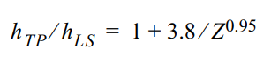

where is the heat transfer of the liquid phase flowing alone in the tube. It is calculated by the following equation:

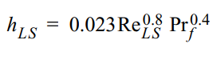

Combining both the equations we get:

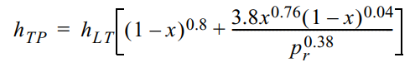

The bracketed term is the two-phase multiplier. This multiplier value depends on the reduced pressure and vapour quality. As the value of the reduced pressure increases, the value of two-phase multiplier reduces. This means that with increasing value of reduced pressure, both phases become similar.

Shah et al.(2009) presented a modified version of the correlation covering a more comprehensive range of mass flux(including lower flux rates), high- pressure ratio values and many new refrigerants. The author presented the correlation for all types of smooth tubes, i.e. horizontal, vertical and inclined.

For horizontal tube new correlation was:

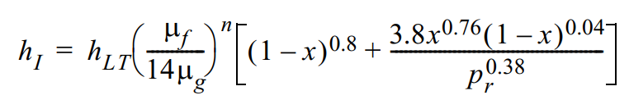

Where,

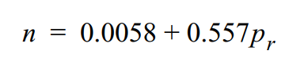

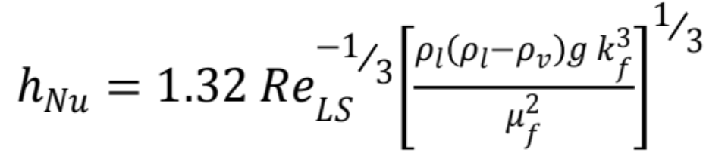

Dobson and Chato (1998) performed an experimental study on the condensation of R12, R22, R134a, R410A and R32/125 (60/40%) in horizontal smooth tubes (3.14, 4.57, and 7.04 mm I.D.). They presented two correlations, which can predict the heat transfer coefficient in the stratifying flow regime and in the annular flow regime, respectively.

Their annular flow condensation correlation is:

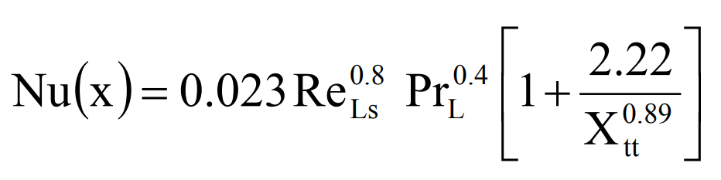

This is the Nusselt equation for laminar film condensation in vertical tubes; the constant has been increased by 20% as recommended by McAdams (1954) on the basis of comparison with test data. This equation can also be expressed in terms of heat flux or temperature difference instead of Reynolds number. This form has been preferred as it is more convenient for this correlation and often it is also more convenient for design calculations.

Ferreira et al. (2003) estimated the heat transfer coefficient of R-404A inside horizontal tubes with smooth, micro-fin, and cross-hatched. The saturation temperature was 40°C, mass flux varying between 200-600 kg/m2s and heat fluxes changing from 5-45 kW/m2. Authors additionally examined the effect of oil concentration on heat transfer and accessed the improvement proportion of 80-140% for both enhanced tubes. In the same year, the author published another paper in which R134a and R410A were used in smooth horizontal tubes and micro fin tubes. The tubes used were flattened in order to investigate the effect of the change of the flow field

Han and Lee (2005) performed experiments on the smaller diameter micro-fin tubes. To make the heat exchangers more compact and reduce the charge of the refrigerant, the diameter of these tubes should be smaller. So, the experiment was performed using different micro-fin tubes having maximum internal diameters of 8.92, 6.46, 5.1 and 4 mm. They studied the condensation heat transfer enhancement and pressure drop penalty factors inside four micro-fin tubes with refrigerants R-134a, R-22, and R-410A. Influence of various parameters like mass flux G, vapor quality x, on condensation process was investigated. Various correlations present at that time were over-predicting both factors for smaller diameter micro-fin tubes, so a correlation was also developed based on heat -momentum analogy

Rahman et al. (2017) in this study outlined the effect of various flow parameters on the heat transfer coefficient and frictional pressure drop in smooth and micro-fin tubes during condensation of R-134a. The experimental results indicated that the micro fin tube performs much better than the smooth tubes, but the pressure drop was higher. The author also validated the experimental results with some famous existing correlations.

Kim et al. (2016,2018) performed an experiment using four different three- dimensional horizontal tubes during condensation of R134a. The authors studied the effect of fin density and fin height on the heat transfer. Authors concluded from the results that with higher fin density and fin height value, the heat transfer coefficient increases. The author also experimented with R404A to obtain the condensation characteristics inside a smooth tube and micro-fin tube of outer diameter 7 mm. The authors found that heat transfer enhancement factor (EF) and pressure drop penalty factor (PF) of R404A increases with increase in mass flux. The range of heat transfer enhancement factor was higher than that of the pressure drop penalty factor.

Conclusions from literature review:

* Most of the studies in the literature review are related to characteristics of condensation heat transfer in smooth horizontal tubes. Authors strongly believe that still there is much scope for more studies on heat transfer mechanism in micro-fin tube surfaces during condensation.
* Almost all published research work related to in-tube condensation has been concentrated mainly on R-12, R-22 and R-123 etc. with significantly less collective work done with modern refrigerants like HFCs and HFOs
* A large number of existing correlations available for establishing heat transfer coefficient and pressure drop, but these correlations do not provide an exact range of operating parameters. This results in seemingly contradicting reports regarding which correlation is the best. Further, there is a need for more reliable experimental data with regards to condensation of new alternative refrigerants in a wide range of micro fin tubes

Objective of the present study:

* To study the effect of Mass Flux and Vapour Quality on Condensation Heat Transfer Coefficient and Effect of Mass Flux and Vapour Quality on Frictional Pressure Drop.
* To compare the condensation heat transfer coefficient of the smooth tube and micro fin tube using some well-known correlations available in the open literature.

**Graphs plot in EES for R134a refrigerant for smooth tubes between heat transfer coefficient and vapour quality with varying mass flux (G)**

Using Shah’s (2009) correlation:

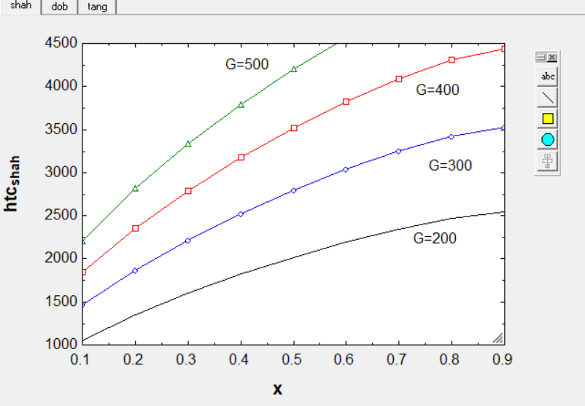

Using Dobson’s (1998) correlation:

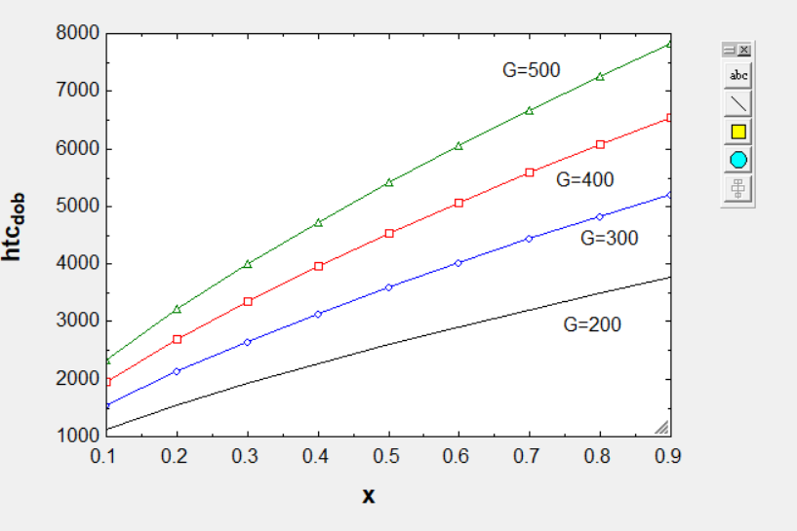

Using tang’s (1997) correlation:

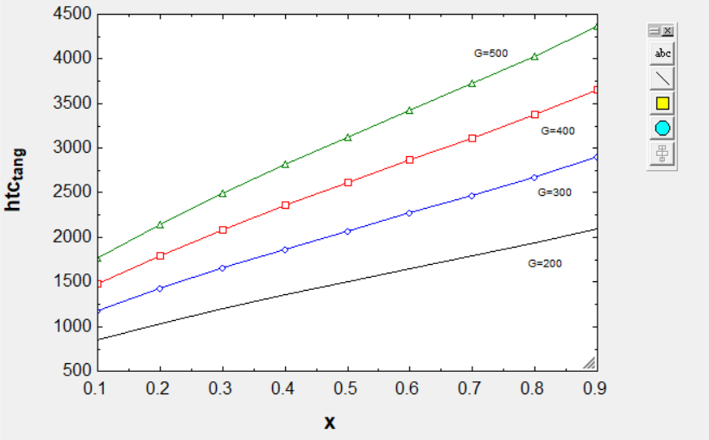

For R410A refrigerant:

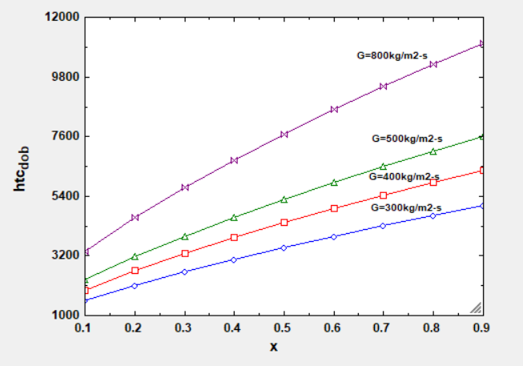

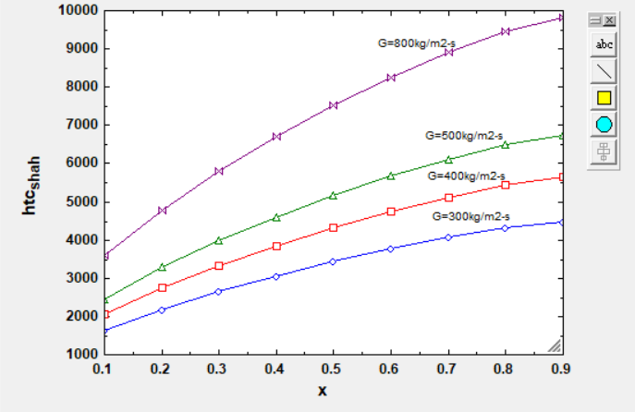

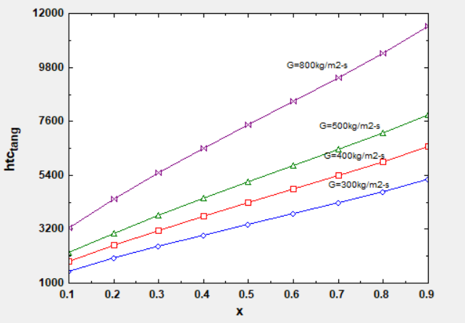

The HTC shows an increasing trend with the mass flux rate, i.e. more the velocity; higher will be the vapour shear which means higher heat transfer coefficient. As the primary mechanism of heat transfer here is convection. So, as mass velocity increases, the Reynolds number increases. Hence, the HTC increases. The condensing heat transfer shows a significant dependence upon vapour quality. The value of HTC decreases with decrease in vapour quality. There are several reasons for this behaviour. One reason is as long as vapour is present, then condensation is taking place, and some amount of heat is transferred as latent heat. So, its implication on the heat transfer coefficient is quite favourable, i.e. heat transfer coefficient will increase. When it is producing subcooled liquid, the heat transfer coefficient will fall. The other reason for this trend is that when a large number of vapours are present, the velocity is high leading to higher heat transfer coefficients

**Variation of The Frictional Pressure Drop Gradient with Mean Vapour Quality and Mass Flux at Saturation Temperature for R134a in Horizontal Smooth Tube**

Using souza & pimenta’s (1995) friction pressure drop correlation:

The momentum pressure drop is calculated using correlations proposed by Souza and Pimenta (1995) equation and because of horizontal orientation, the pressure drop due to gravity is zero. Two-phase frictional pressure drop was obtained by subtracting the calculated momentum pressure drop from the total measured pressure drop. The frictional pressure gradient is calculated by dividing the length of the test condenser

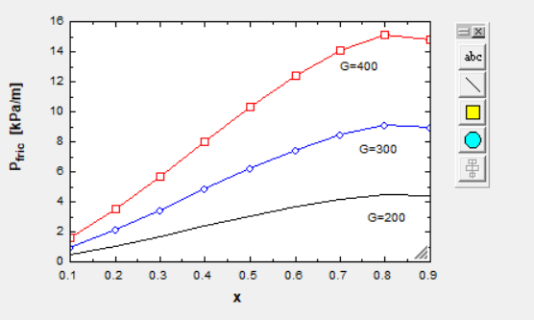

**Variation of Condensation Heat Transfer Coefficient of R-134a at Saturation Temperature of 35°C Inside a Micro Fin**

using koyama (1990) correlation for Microfin Tubes:

For helix angle 18 degree-

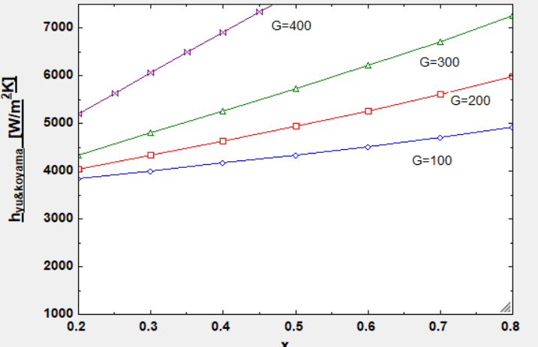

For helix angle 10 degree-

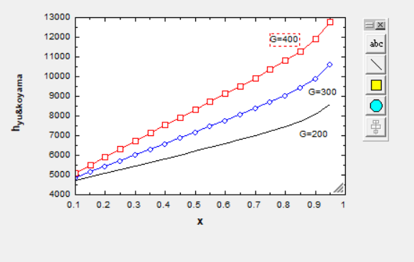

**Variation of The Frictional Pressure Drop Gradient with Mean Vapour Quality and Mass Flux at Saturation Temperature for R134a in Horizontal microfin Tube**

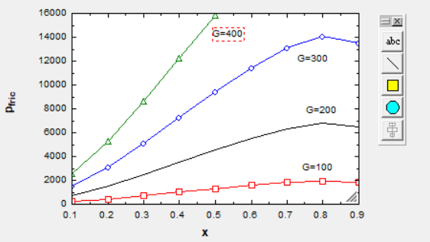

As can be seen here the magnitude of pressure drop gradient rises with the increase in mass flow rate and vapour quality during condensation in a smooth tube. The same trend is noticed in the micro fin tube, but magnitude was higher. This increased value of the pressure drop is due to the higher turbulence in the flow generated due to the fins. The fins delay the onset of the stratified flow regimes by redistributing the liquid condensate around the tube's periphery. Hence, larger values of pressure drop gradient are observed in comparison to the smooth tube.

HEAT ENHANCEMENT FACTOR-

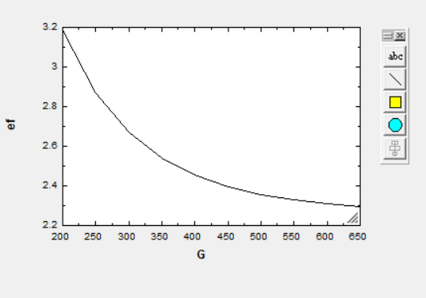

Here it can be seen that at higher mass flux, the micro fins do not increase heat transfer coefficient to much extent as already the coefficient are higher due to high turbulence at high flow rates.

**RESULT AND DISCUSSION:**

* As mass flux rate increases the heat transfer coefficient increases in smooth tubes i.e. more the velocity; higher will be the vapour shear which means higher heat transfer coefficient.
* As the refrigerant's vapour quality and mass flux increases, the pressure gradient along with the test condenser increases. At high vapour qualities and flow rates, the flow is shear dominated, and the pressure drop is due to the increased turbulence created by the high-velocity vapour, which also generates friction at the vapour-liquid interface. As the condensation progresses, the vapour quality decreases and stratification (division of layers) of the flow takes place, and the flow becomes gravity dominated. During these gravity dominant flows, the velocity of vapour and liquid becomes nearly equal, due to which the pressure gradients become lower. Due to this transition of the flow regimes, the pressure gradient was lower at low flow rates of 100- 200kg/m2s and mean vapour quality 0.1-0.5 and increases with increases in both parameters.
* For microfin tubes from the graph plotted between heat transfer coefficient and vapour quality it can be seen that heat transfer coefficient of R-134a increases with increasing mass flux ranging between 200-500 kg/m2s and vapour quality ranging between 0.1-0.9. At low mass 47 flux, 200-300 kg/m2s, and vapour quality 0.1-0.4, heat transfer coefficients increase gradually because of gravity dominated flow regimes. At high mass fluxes 400- 500kg/m2s and vapour quality 0.5-0.9 value of vapour shear forces increase rapidly. Hence the shear-dominated regimes will be there, which increases heat transfer coefficients.
* At higher mass flux, the micro fins do not increase heat transfer coefficient to much extent as already the coefficient are higher due to high turbulence at high flow rates.
* The frictional pressure gradients increase with the increase of mass fluxes (200-500 kg/m2s) and vapour quality (0.1-0.9). This trend was common for both smooth and micro fin tubes. The values of Pressure gradient are higher in micro- fin tube (generally 80 - 90% higher) compared to smooth tubes.

Images of R-134a condensing at a mass flux of 500 kg/m2 s for the two tubes

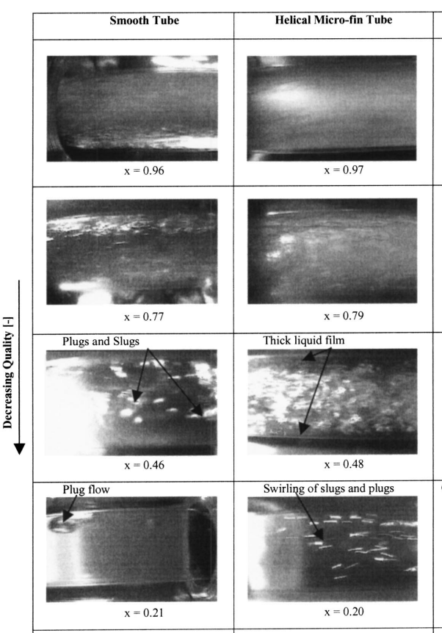

About EES (engineering equation solver):

Engineering Equation Solver (EES) is a commercial software package used for solution of systems of simultaneous non-linear equations. It provides many useful specialized functions and equations for the solution of thermodynamics and [heat transfer](https://en.wikipedia.org/wiki/Heat_transfer) problems, making it a useful and widely used program for mechanical engineers working in these fields EES stores thermodynamic properties, which eliminates iterative problem solving by hand through the use of code that calls properties at the specified thermodynamic properties.

Using the existing correlations for the smooth tubes and microfin tubes in the open literature the equations were solved for R134a refrigerant at saturation temperature of 35 degrees Celsius.

EES also includes [parametric tables](https://en.wikipedia.org/w/index.php?title=Parametric_tables&action=edit&redlink=1) that allow the user to compare a number of variables at a time. [Parametric tables](https://en.wikipedia.org/w/index.php?title=Parametric_tables&action=edit&redlink=1) can also be used to generate plots, so using the parametric table and calculating the value of heat transfer coefficient for different values of mass flux rate the graphs were plotted.

Future scope of work:

1. Microfin tubes with different geometries like helix angle, apex angle, fin density, angle of inclination can be tested for enhancement of performance

2. More experimental investigations is needed for calculating the effect of geometrical parameters of micro-fin tubes for a new generation of refrigerants, i.e., hydrofluoroolefins such as R1234yf, R1234ze, etc. 4. The effect of oil on the flow regimes needs to be probed further, especially for the HFC and HFO refrigerants.

3. Most of the experiments in the literature review have been conducted in the range of vapour quality of 0.1-0.9. Experimental studies need to be conducted at very low vapour quality less than 0.1 and at high vapour quality greater than 0.9 to understand the flow regime transitions in these mass flux and vapour quality ranges.

Bibliography:

* Dobson, M.K., and Chato, J.C., 1998, “Condensation in Smooth Horizontal Tubes,” ASME Journal of Heat Transfer
* Eckels, S.J., and Pate, M.B., 1991, “Evaporation and condensation of HFC-134a and CFC-12 in a smooth tube and a micro-fin tube,” ASHRAE Trans, Vol.97, pp.71-81. Fujie K., Itoh N., Kimura H., Nakayama N., and Yanugidi T., 1977, “Heat transfer pipe,” US Patent 4044797, assigned to Hitachi
* Cavallini, A., G. Censi, D.D. Col, L. Doretti, G.A. Longo, and L. Rossetto. 2001. Experimental investigation on condensation heat transfer and pressure drop of new refrigerants (R134a, R125, R32, R410A, R236ea) in a horizontal smooth tube. Int. J. Refrig. 21:73–87
* Rahman, M.M., Kariya, K., and Miyara, A., 2017, “Experimental investigation of condensation heat transfer and adiabatic pressure drop characteristics inside a microfin and smooth tube,” International Journal of Air-Conditioning and Refrigeration, Vol.25, No.3, 175002
* Shah M.M., 1979, “A general correlation for heat transfer during film condensation inside pipes,” Int J Heat Mass Transfer, Vol.22, pp.547-56.
* Shah M.M., 2009, “An Improved and Extended General Correlation for Heat Transfer during Condensation in Plain Tubes,” HVAC&R RESEARCH, Vol.15, pp.889-91
* Shah M. M., 2013, General correlation for heat transfer during condensation in plain tubes: further development and verification, ASHRAE Trans.
* Carnavos, T. C., 1980, ‘‘Heat Transfer Performance of Internally Finned Tubes in Turbulent Flow,’’ Heat Transfer Eng.
* Souza, A. L., and Pimenta, M. M., 1995, ‘‘Prediction of Pressure Drop During Horizontal Two-Phase Flow of Pure and Mixed Refrigerants,’’.